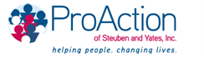

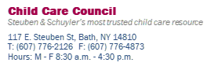

Pro Action Child Care Council Funding Sources

Programs within Pro Action Child Care Council are funded through:
- New York State Office of Children and Family Services
- New York State Department of Health
- Steuben County Department of Social Services
- United Way
- Fee service programs
- Local foundation grants

Individual community members interested in making a donation to further the work of Pro Action Child Care Council may contact the Director, Margie Lawlor at 607-776-2126 Ext. 9100 or lawlorm@proactioninc.org

