Professional Early Childhood Organization Links

Child Care Aware® of America
http://childcareaware.org/
Early Care & Learning Council
http://www.earlycareandlearning.org/
National Association for the Education of Young Children
www.naeyc.org
National Association for Family Child Care
www.nafcc.org
Family Child Care Association of New York State
www.fccanys.org
New York Association for the Education of Young Children
www.nyaeyc.org
NYS Early Childhood.org
www.earlychildhood.org
Council for Professional Recognition
www.cdacouncil.org
Center for Exceptional Children
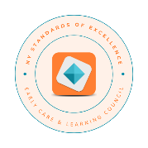
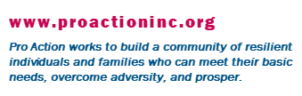
www.exceptionalchildren.org

